Terraform is infrastructure management tool. With this you can integrate with any cloud service I say any. It is supportable to configure management tool like Ansible also, like creating AWS infrastructure with Terraform and calling configure management script to configure the infra.
Here we are using AWS services to setup an infrastructure. For that we have few requirements listed below.
IDE tool: Atom/visualstudio (currently we don’t use for this tutorial)
Authentication and Authorization: we use AWS IAM user for Authentication and Authorization.
Authentication and Authorization:
If you want to setup an Infra you need access for services in AWS. For that you need authentication and authorization, for that we are using IAM user to give access for AWS services.
To create IAM user first we login to AWS console and then search for IAM. You will get IAM service as search result click on it.
Now go to left side click on users it will take you to create user option as shown in below image.
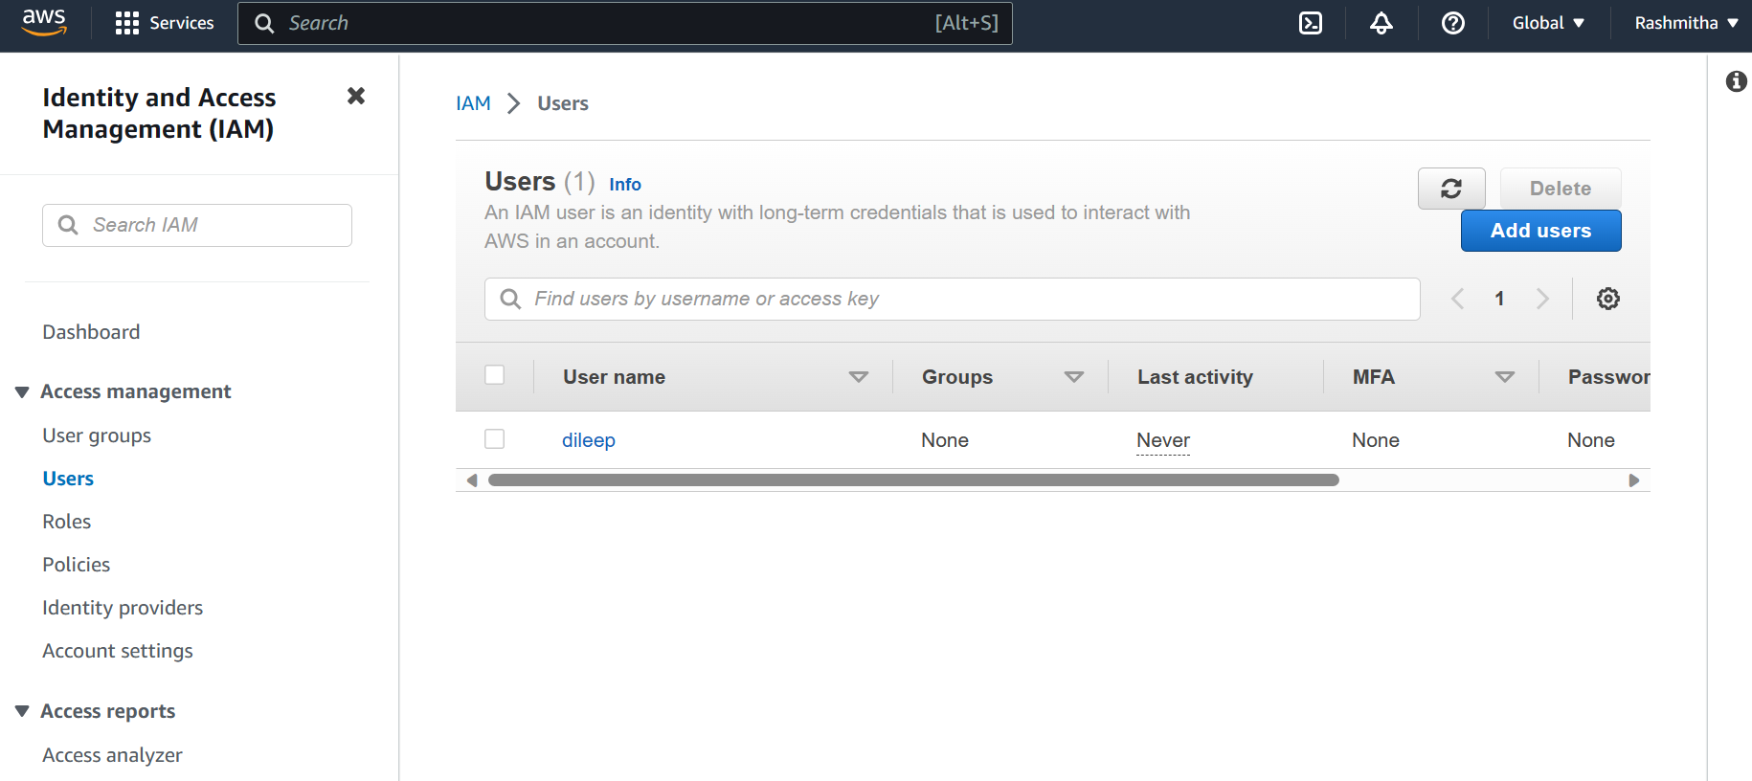
Now click on Add users -> give name to the user
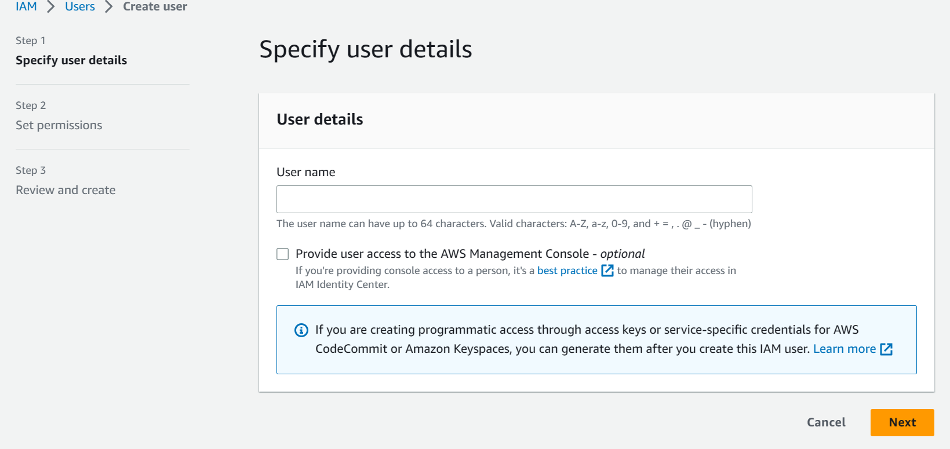
After giving the name click on Next button -> It will take to “set permissions” select attach policies
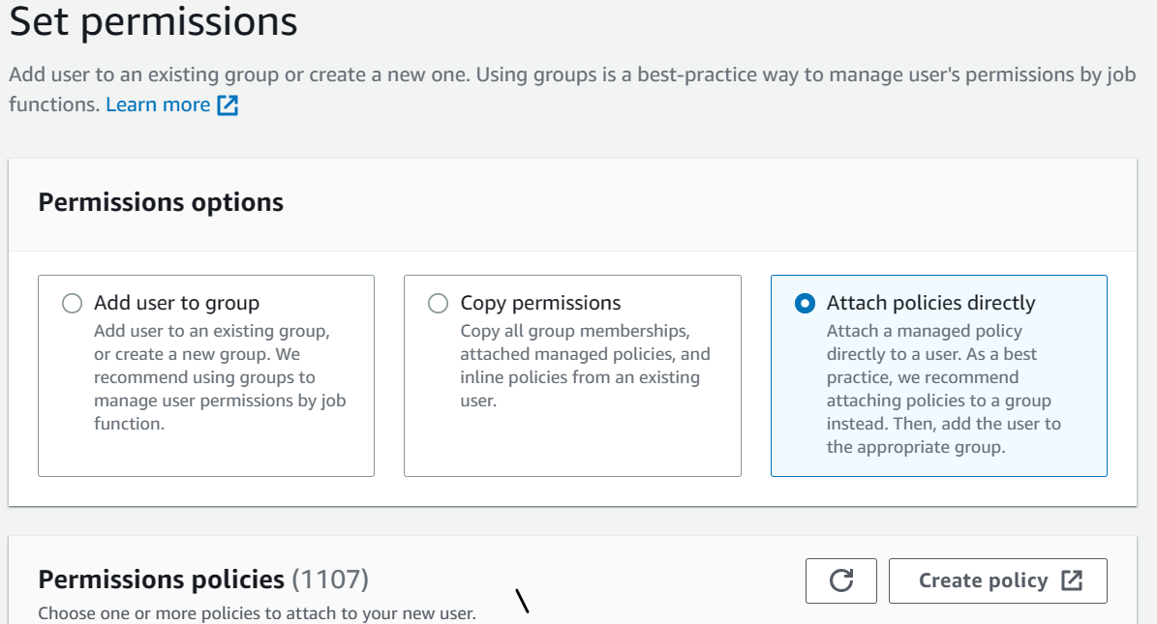
Now go to permissions policies -> now search for “administration access” give check mark and click on next click on create user
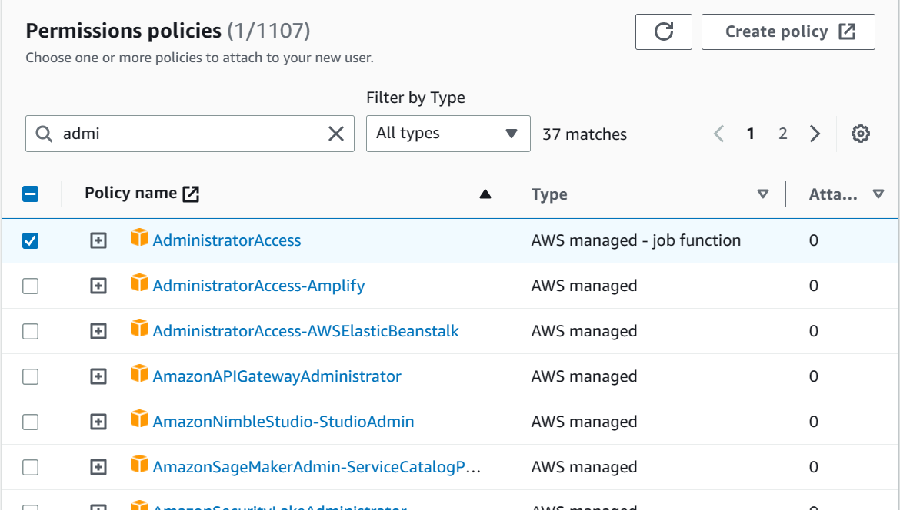
Now go to “security credentials” “access keys” click on “Create access key”
After clicking on it will take to below page.
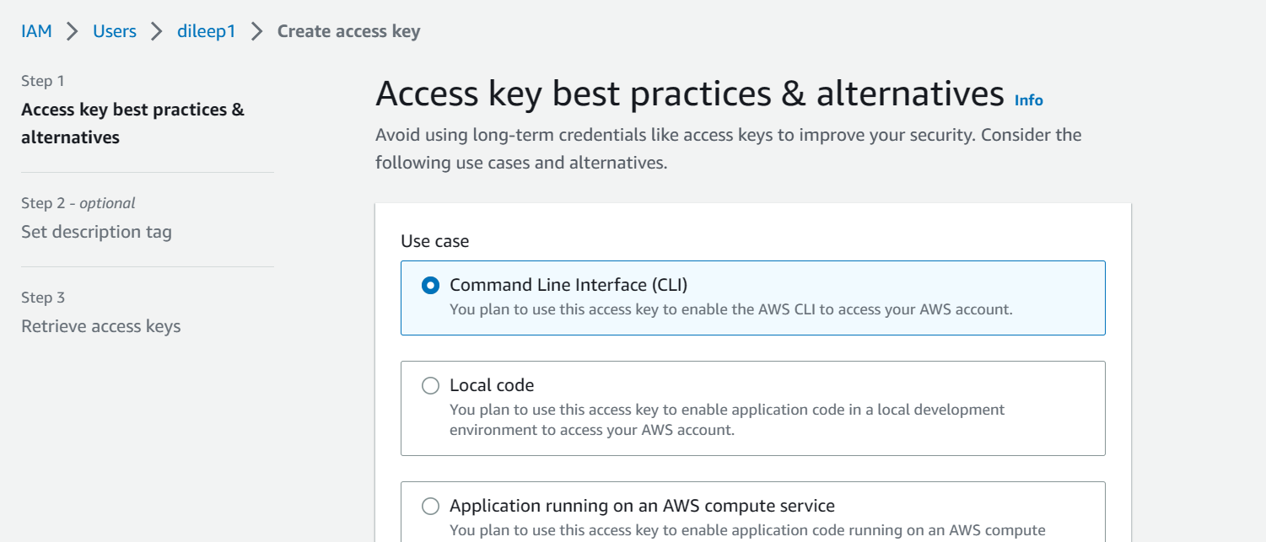
Select “Command Line interface (CLI)” after clicking on next, it will ask for description write description and click on “create access key”. Now it will generate “AWS access key” and “AWS secret access key” save the both for future purpose in private space.
With this now we are going to access AWS services with Administration level access.
Terraform on Linux Machine: To install this we need to go to Install | Terraform | HashiCorp Developer select Linux there you can see multiple flavours. Here I’m using Amazon linux, so I’m using below commands to install terraform
sudo yum install -y yum-utils shadow-utils
sudo yum-config-manager --add-repo https://rpm.releases.hashicorp.com/AmazonLinux/hashicorp.repo
sudo yum -y install terraform
after installing it run “terraform” command it will display list of commands which we can use in terraform.
Now we will write terraform script the extension of it should be “.tf”.
Now run “terraform init” it will install required plugins to execute. Whenever we define new provider i.e., “aws” here if it is azure we will use “azurerm” we need to run “terraform init” then it will download required plugins.
Task 1: How to create a simple ec2 instance with the name?
I’m using below script.
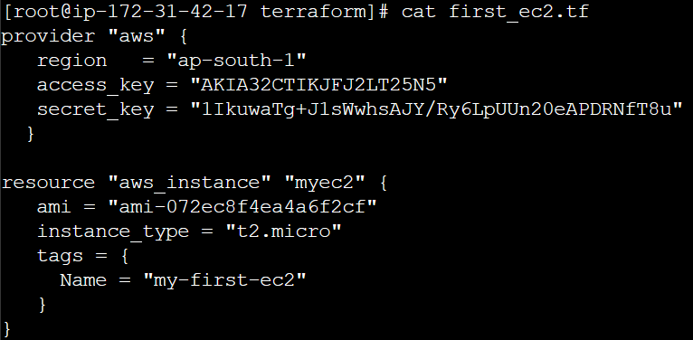
After writing above script to “first_ec2.tf” file run “terraform plan” it will show you the list of changes to be added, changed & destroyed like below image.
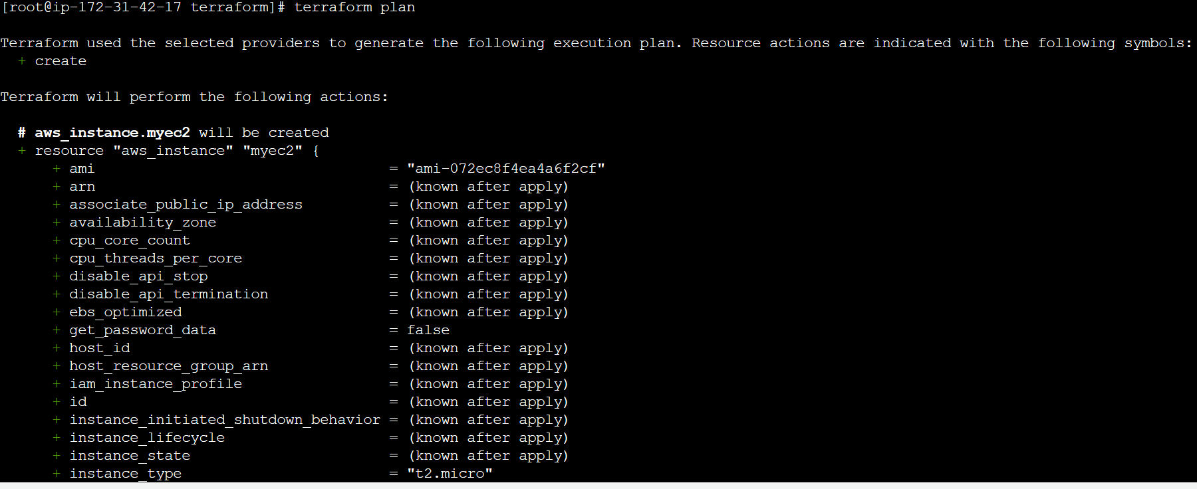
Once verifying it run “terraform apply”.
Again it will show the above list and it will ask for confirmation to proceed after typing “yes” the ec2 instance will be started with the mentioned name in the tag “my-first-ec2”.

Provider & Resource:
- Provider: Whenever you mention new provider to .tf file you need to run “terraform init” command.
- Resource: Resource should be the default value.
Eg: Resource “aws_instance” “myec2”
Here ‘aws_instance’ is resource is should be default value. We should not change the value. However, ‘myec2’ is resource name is for user convenience. But, we can’t use same name for 2 resources it will display error while running.
Question:
Do I have to learn Terraform for each provider?
Ans. No, Just basics and syntax of terraform is enough to deal with multiple providers.
Eg: The answer for above question we will see an example with github provider. Here we are going to create a new repo with the help of terraform script.
First create a ‘github.tf’ file. To Authenticate github, we need github token for that login to github click on avatar on top right side->settings->Developer settings->personal access token->Fine-grained tokens-> click on generate personal access token.enter the name of the token, select ‘All repositories’ in ‘Repository access’. Now go to ‘Repository Permissions’ -> In ‘Administration’ permission select ‘Read and Write’ permission and click on generate token. Store the token somewhere safely with aws keys.
Provider configuration: Since github is not maintained by hashicorp. We need to mention the provider differently as mentioned below.
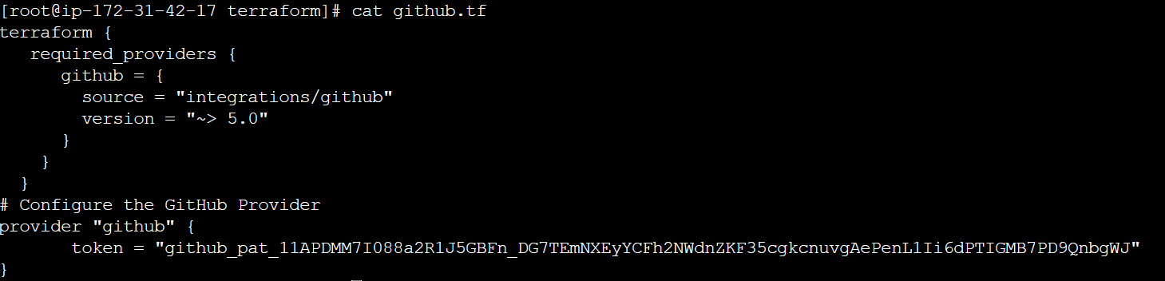
From above script we will call the github provider for reference open this link Docs overview | integrations/github | Terraform | Terraform Registry and we need to add the github PAT which we generated in previous step.
Now we need to create a repository, go to Docs overview | integrations/github | Terraform | Terraform Registry on left side click on ‘Resources’ you can see multiple resources which it will help to configure the github here our requirement is creation of repo for that we will select ‘github_repository’ it will show the script which we will add in .tf file.The script looks like below.
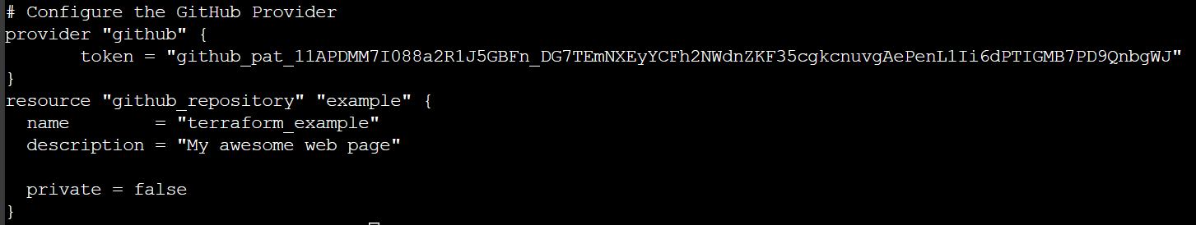
And the whole script would be like this.
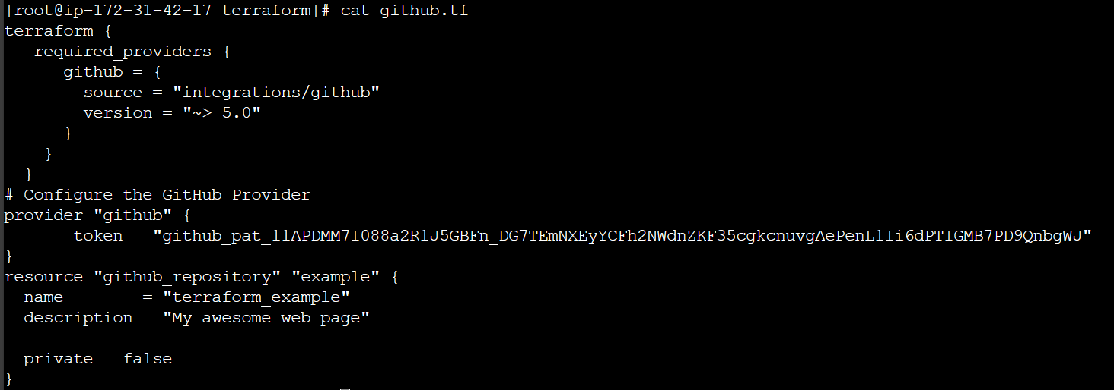
After adding the script run ‘terraform apply’. It will create a repo in your github with the name of ‘terraform_example’.
Like this we can create the requirements of other providers also.
Destroy Resources:
If you keep infra running, you will get charged for it.
Hence it is important to know how to delete the infra resources created via terraform.
To remove the resources which we generated with ‘first_ec2.tf’ and ‘github.tf’ we will use ‘terraform destroy’ command with we can remove the resources which we created from above files.
If you want remove particular resource we will use -target flag along with that we need to specify resource and resource name & command would be ‘terraform destroy -target aws-instance.myec2’.
Another way to destroy the resource is commenting the code and running the ‘terraform apply’. Whenever you comment the code the terraform will think that the created resource is no more required. PFB SS.
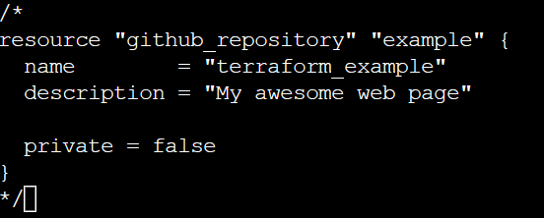

Terraform state file:
How terraform knows that a resource is created or not if it’s not created it will create?
Terraform stores the state of the infra that is being created from the TF files.
This state allows terraform to map real world resource to your existing configuration.
Eg: I you create any resource with the help of TF file, terraform will store that info in state file. If you delete the resource the info in the state file also gets removed. Similarly if any resource is removed TF will first check in state file if it’s there it won’t create otherwise it will create. The filename is ‘terraform.tfstate’.
*** don’t touch terraform.tfstate file & take a backup of the file is suggested.
Desired & Current state:
- Desired state: Terraform’s primary function is to create, modify and destroy infra resources to match the desired state described in a terraform configuration that means it will do whatever mentioned in the configuration. If you try to change the config which not mentioned in TF file, it won’t show in modified state.
- Current state: Current state is the actual state of a resource that is currently deployed.
Terraform tries to ensure that the deployed infrastructure is based on the desired state.
If there is a diff between the two, terraform plan presents a description of the change necessary to achieve the desired state.
Provider Versioning:
Provider pulgins are released separately from Terraform itself & they have different set of version numbers.
If you don’t provide provider version vi TF file it will take latest one. This may impact on PROD because there are few scenarios where it may not get supported in this situation resource may not create properly.
Terraform dependency lock file allows us to lock to a specific version of the provider.
If a particular provider already has a selection recorded in the lock file, terraform will always re-select that version for installation, even if a newer version has become available.
You can override that behvaiour by adding -upgrade option when you run terraform init.
Terraform init -upgrade
Terraform refresh:
The ‘terraform refresh’ command will check the latest state of your infra and update the state file accordingly.
You shouldn’t typically need to use this command, because TF automatically performs the same refreshing actions as a part of creating a plan in both the terraform plan and terraform apply commands.
Note: ‘terraform apply -auto-approve’ this one will create the resource without prompting for yes confirmation.
Don’t use ‘terraform refresh’ it may delete whole info in state file.
AWS provider – Authentication configuration:
How to avoid adding access keys in TF file?
For that we need to configure credentials in AWS CLI for that run ‘aws configure’ it will ask for aws access key and secret key add it and save it. Now remove the keys mentioned in TF file and save it. Now run ‘terraform apply’ it will create the desired resources in AWS.
Where these keys will be stored?
The default path for keys storage is /root/.aws/credentials. Here I’m running from root user If it’s not super user the path would be /hom/.aws/credentials.

